

**Don’t be a “man on the street”**

* Remember that not ALL customers have access to the internet or   
  like online shopping, so selling exclusively online may not be appropriate for all businesses
* Amazon is a third party – a significant number of its products are produced by other businesses

**Synoptic Links**

**Technology –** has enabled more businesses to become e-tailers, and for small businesses to use third-party platforms

**Globalisation** – using third party platforms enables more businesses to sell worldwide

**Customer needs** – channels can meet needs of convenience

**Market segmentation** – the channel needs to be appropriate for the market segment

**Core Knowledge**

Place is NOT to be confused with location*. It is about how the product gets to the consumer and which other businesses it needs to pass through, not the physical location of the premises*.

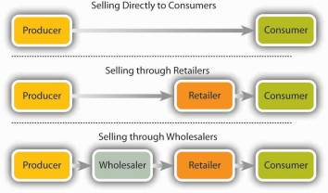

The more third parties in the channel, the greater the mark-up and so the higher the price for the consumer

**Key Vocabulary**

**Distribution –** how ownership changes as a product goes fromproducer to consumer

**Producer –** the business or individual who makes the product / service

**Wholesaler –** a businessthatbuys in bulk from a producer and sells onto to retailers in smaller quantities

**Retailer –** a shop or chain of shops, usually selling from a building on the high street or shopping centre

**Agent –** a business that sells something on behalf of the producer but never owns the product, e.g. a travel or estate agent

**Customer –** the person or business who buys the product

**e-tailer –** an electronicretailer

**Mark-up –** the additional amount added to the price of the product as it moves through the distribution channel

**Third-party platform –** an e-commerce website or service that is run by an unrelated business where businesses can sell their products

**Topic 2.2.4 Place**

**Wider Business World**

**Amazon** – an example of a third party retailer

**Booker** – an example of a wholesaler

**NEXT** – a business that is a retailer and e-tailer

**ASOS** – an e-tailer

**BUSINESS**: ***Creating informed, discerning employees, consumers and future leaders***