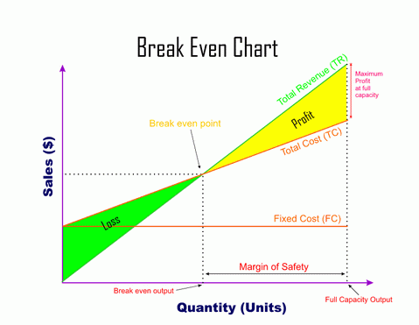

**Topic 1.3.2b break even**

**Key Vocabulary**

**Revenue –** Also called **Turnover**, **Income** and **Sales**. This is the money generated from selling your products

**Output** – quantity of products produced

**Fixed costs –** costs that do not change as the level of production changes. They must be paid even if output/sales are zero, e.g. rent, rates

**Variable costs –** costs that change in direct relation to the amount sold or produced by a business, e.g. raw materials, packaging

**Total costs –** All costs added together

**Profit** – when revenue is greater than costs

**Loss** – when revenue is lower than costs

**Breakeven point –** when total revenue = total costs

**Breakeven output** – the number of products needed to break-even

**Margin of safety** – number of products produced above breakeven

**Don’t be a “man on the street”**

* A business can easily lower the breakeven point by reducing costs  
  - this may not be true. Fixed costs are out of the control of the business, and buying lower cost materials can affect quality
* Increasing price will make more profit for a business – not always! Increasing the price, will lower the breakeven point, BUT may lead to lower sales

**Core Knowledge**

Calculating breakeven allows a business to use all its costs to calculate how many products it must sell to cover ALL costs.

The contribution method is a quicker, more accurate way to calculate breakeven:

**Break-even** = Fixed costs ÷ (Selling price – variable cost)

**Wider Business World**

**Gordon Ramsey –** watch any of his ‘Nightmare’ shows to see how he talks about knowing the break-even number of meals, and the importance of costing each meal

**High street retailers** – consider the impact of COVID19 on the breakeven point of most retailers: what were their costs and revenue during this period

**Synoptic Links**

**Costs –** knowing the difference between fixed and variable costs and being able to calculate costs and revenue

**Aims** – breakeven (survival) is an aim for a start-up business, or one in a struggling market

**Business plans** – this information is needed in the plan to present to investors