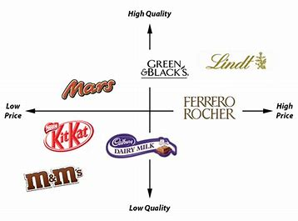

**BUSINESS**: ***Creating informed, discerning employees, consumers and future leaders***

**Topic 1.2.3 Market segmentation and market mapping**

**Key Vocabulary**

**Market segmentation –** splitting up all consumers into different groups that have similar needs or characteristics

**Target market** – the specific market segment a business aims to sell to

**Demographics** – customers based on statistical data relating to the population, e.g. resident or marital status

**Market map** – a diagram that positions all products within a market using two features, e.g. price and quality

**Socio-economic group** – a method of segmenting that uses income and class / occupation to classify people

**Don’t be a “man on the street”**

* Don’t assume that a gap on a market map indicates a gap   
  to be filled – it could be there because there is no demand for that type of product
* Be careful not to say ALL or WILL – adapt to MOST, MORE LIKELY, e.g. *Most* women are *more likely* to buy make-up than men

**Core Knowledge**

Markets can be segmented by

* **Location**, i.e. where you live
* **Demographics**, e.g. targeting families rather than single people; home owners rather than renters
* **Lifestyle**, i.e. the choices made about how to spend free time and hobbies consumers have
* **Income**, i.e. by how much you earn, the job you do or your social class
* **Age,** i.e. by how old you are

A market map can be used to position and compare products in a market

Allows a business to identify the   
competition the business faces and  
any potential gaps in the market

BUT….this may be simplistic and is  
based on subjective opinion so may not  
be reliable

**Wider Business World**

**Hotel market** – consider the target market of the Savoy compared to a Premier Inn

**Ford cars** – products lots of products to target different segments

**Taylor Wimpey** – a house builder. They produce lots of varieties of new homes to target different groups in terms of income, location and   
family size

**Synoptic Links**

**Market research** – information gathered can help a business to identify which segments to target

**Marketing mix** – the elements of marketing. These will be different for different target markets